Lab: Typelists

Overview

In this lab, you will add fields using typelists in TrainingApp. The new fields are relevant to labs later in the course.

Tasks

1. Find the ContactTier typelist and open it in the editor (double-click).

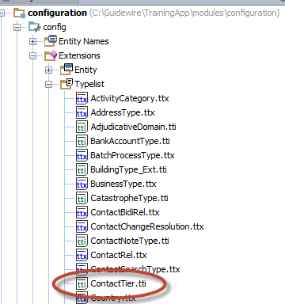

1. Add a “Bronze” typecode to the **ContactTier** typelist that displays between “Silver” and “Unknown”. Take care in the naming convention and priority setting.
2. Create the following new typelists:
   1. **InteractionReason_Ext**, which has these choices displayed in this order:
   * Request
   * Complaint
   * Courtesy contact
   * Other
   1. **ChannelType_Ext**, which has these choices displayed in this order:
   * Email
   * Phone
   * Postal mail
   * Fax
   * In person
   * Other
3. Add the following fields to the following entities:

* For ABContact, add a field for "contact tier" that points to the **ContactTier** typelist
* For Interaction, add a field for "reason" that points to the **InteractionReason_Ext** typelist
* For Interaction, add a field for "channel" that points to the **ChannelType_Ext** typelist

After the new additions, the entity diagram is more complex, as follows.

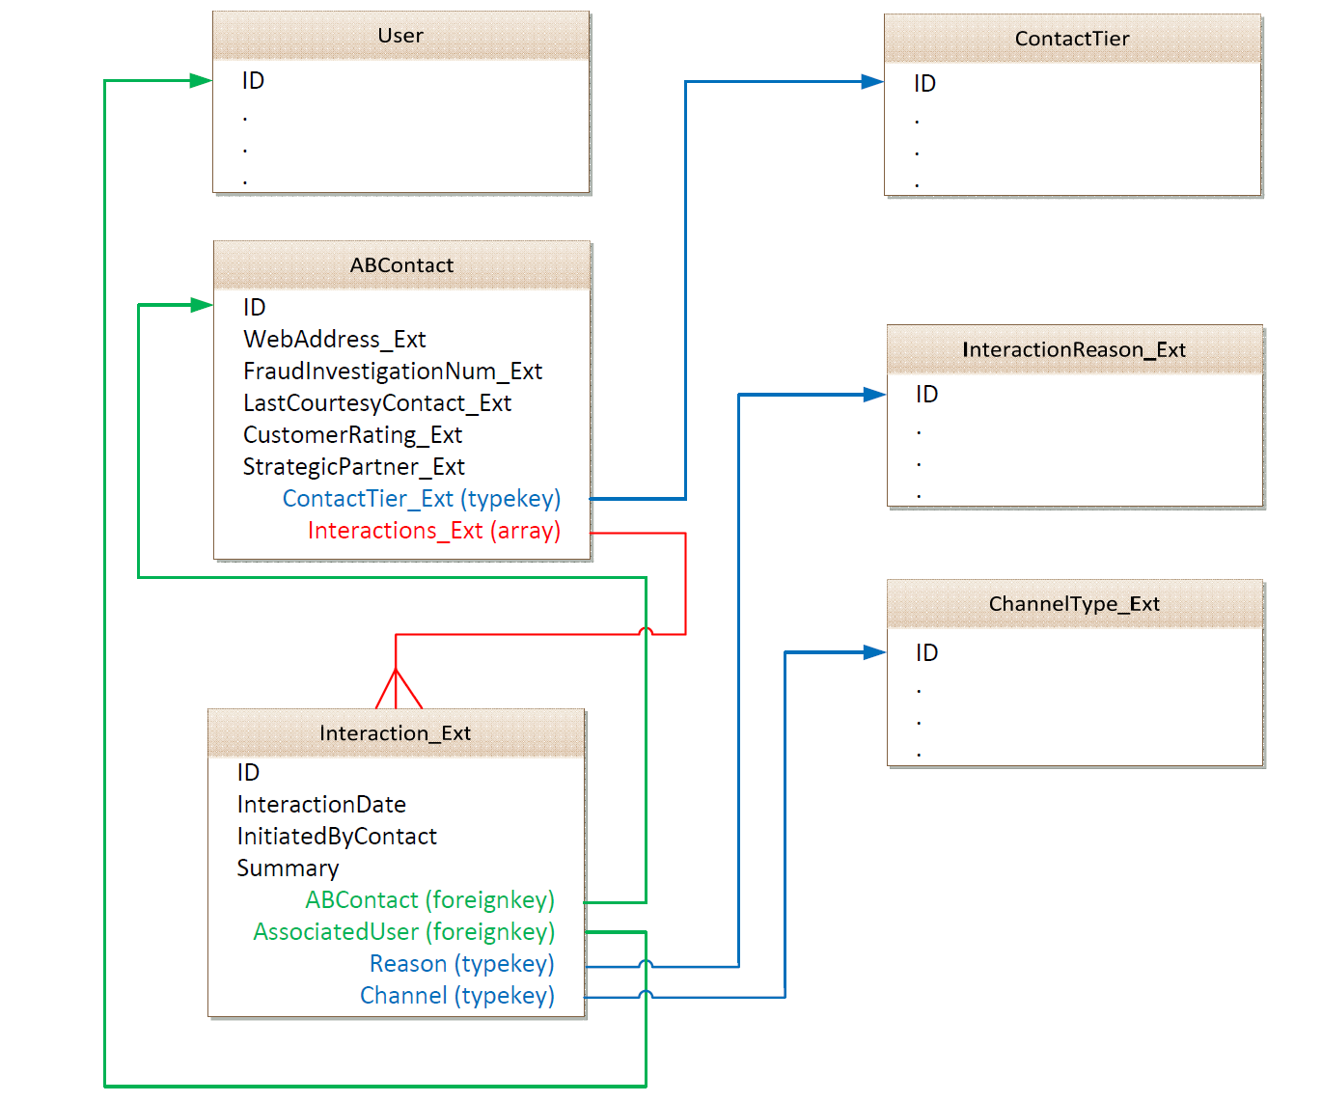

Verification

1. Regenerate the Data Dictionary and verify that the fields and their corresponding typelists are listed.
2. Deploy your data model changes.

|  |  |
| --- | --- |
|  | Stop and ask your instructor to review your completed lab or compare your solutions with the available solution set. |